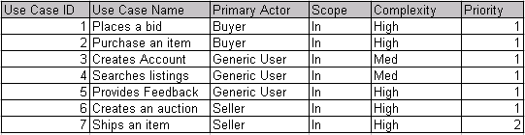

|  |  |  |  |  |  |
| --- | --- | --- | --- | --- | --- |
| Use Case ID | Use Case Name | Primary Actor | Scope | Complexity | Priority |
| 1 | Make a Booking for Myself | Game Café Member | In | Medium | 1 |
| 2 | Make a Booking for a Non-Member | Game Café Member | In | Medium | 2 |
| 3 | Get Ticket for an eSports Event | Game Café Member | In | Medium | 1 |
| 4 | Manage Current Booking Information | Game Café Staff Member |  |  |  |
|  |  | Game Café Staff Member |  |  |  |
|  |  | Game Café Staff Member |  |  |  |
|  |  |  |  |  |  |